Impact Assessment Template Compliance Guidance   
(APS Group)

Good accessible content begins with the creation of clean content. Please use all parts of the guidance and the template provided, as all three pieces are interdependent.

In conjunction with the Impact Assessment Word template please refer to the [APS Publishing Compliance Guidance](https://sgpublishingcompliance.theapsgroup.scot/) which gives advice on accessibility compliance when preparing your document.

In addition to that guidance, this document highlights some of the key requirements, along with visual examples.

Please contact APS when you have a draft version completed to request a quote and initial accessibility compliance check of your draft file. This will allow any issues to be addressed in advance of providing the final version for publication.

Contact: [scotgovenquiries@theapsgroup.com](mailto:scotgovenquiries@theapsgroup.com)

Contents

Introduction 3

Front Cover 3

Table of contents 3

Headings 3

Heading 1 (Arial 20pt bold) 4

Heading 2 (Arial 16pt body) 4

Heading 3 (Arial 12pt bold) 4

Bordered text 4

Tables 5

Charts and Images 6

Accessibility compliance 6

Back cover 7

# Introduction

Applying the supplied styles outlined in this document in conjunction with the Impact Assessment template and the [APS Publishing Compliance Guidance](https://sgpublishingcompliance.theapsgroup.scot/) will help to ensure your publication content is accessible and can easily be converted to HTML content for publishing on gov.scot.

Users are encouraged to complete a new version of the Impact Assessment template when beginning a new publication, rather than updating previous publications. This will help prevent potential formatting issues being introduced and carried forward from one publication to the next which may result in inaccessible content.

Content authors should endeavour as far as possible to follow the Impact Assessment template in order to comply with SG accessibility guidelines, reducing the need for multiple accessibility checks.

# Front Cover

All documents require a standard cover to be applied with the correct Scottish Government branding.

# Table of contents

When including a table of contents please apply the correct heading styles. The Table of Contents (TOC) can be updated automatically to include the correct page numbers in the document.

# Headings

This section illustrates the formatting styles that should be used when developing a publication. It is important that text is properly formatted using these styles to ensure that the document structure can be understood by readers using assistive screen reading technology.

Users should avoid introducing additional styles, such as bold or italicized text. Publications should use a maximum of three levels of headings.

Please note: you can adjust the sizes of the headings by modifying both the font and font size settings in the style options to your preference particularly where you may only require 1 or 2 heading levels in your document. The point size may vary according to how many heading levels you are using in your document. In this example we are using 3 heading levels of 20pt, 16pt and 12pt.

The headings and styles to be used in publications are as follows:

# Heading 1 (Arial 20pt bold)

## Heading 2 (Arial 16pt body)

### Heading 3 (Arial 12pt bold)

Normal text (Arial 12pt)

# Bordered text

To emphasis text with a border please only use the Borders styling available, as follows:

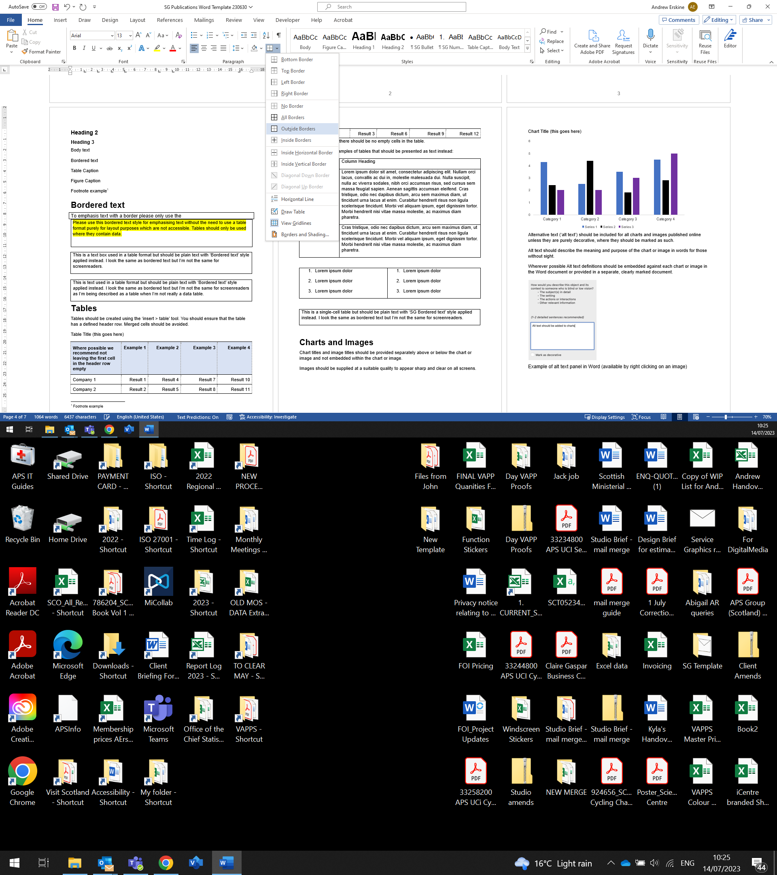

This text is highlighted correctly through the use of the above Border styling. Whilst there are other ways to apply borders these should be avoided, as explained in the below examples.

This is text where a text box has been inserted to create the border. I look the same as the above bordered text but I can be problematic for screen readers and should not be used.

|  |
| --- |
| This is text where a single cell table has been used to create the border. I look the same as the above bordered text but I can be problematic for screen readers and should not be used. |

# Tables

Tables should be created using the ‘insert > table’ tool. You should ensure that the table has a defined header row. Merged cells should be avoided.

Table Title (this goes here)

|  |  |  |  |  |
| --- | --- | --- | --- | --- |
| Where possible we recommend not leaving the first cell in the header row empty | Example 1 | Example 2 | Example 3 | Example 4 |
| Company 1 | Result 1 | Result 4 | Result 7 | Result 10 |
| Company 2 | Result 2 | Result 5 | Result 8 | Result 11 |

Whenever possible there should be no empty cells in the table.

Tables should only be used for data and not layout or design purposes. Below are some examples of incorrect table use, where these should be presented as plain headings and text instead.

|  |  |
| --- | --- |
| **Column Heading** | **Column Heading** |
| One | Lorem ipsum dolor sit amet, consectetur adipiscing elit. Nullam orci lacus, convallis ac dui in, molestie malesuada dui. Nulla suscipit, nulla ac viverra sodales, nibh orci accumsan risus, sed cursus sem massa feugiat sapien. Aenean sagittis accumsan eleifend. Cras tristique, odio nec dapibus dictum, arcu sem maximus diam, ut tincidunt urna lacus at enim. |
| Two | Lorem ipsum dolor sit amet, consectetur adipiscing elit. Nullam orci lacus, convallis ac dui in, molestie malesuada dui. Nulla suscipit, nulla ac viverra sodales, nibh orci accumsan risus, sed cursus sem massa feugiat sapien. Aenean sagittis accumsan eleifend. Cras tristique, odio nec dapibus dictum, arcu sem maximus diam, ut tincidunt urna lacus at enim. |

|  |  |
| --- | --- |
| 1. Lorem ipsum dolor 2. Lorem ipsum dolor 3. Lorem ipsum dolor | 1. Lorem ipsum dolor 2. Lorem ipsum dolor 3. Lorem ipsum dolor |

# Charts and Images

Chart titles and image titles should be provided separately above or below the chart or image and not embedded within the chart or image.

Images should be supplied at a suitable quality to appear sharp and clear on all screens.

Chart Title (this goes here)

Alternative text (‘alt text’) should be included for all charts and images published online. Alt text helps screen-reading tools describe images to visually impaired reader.

Alt text should describe the meaning and purpose of the chart or image in words for those without sight.

Alt text should be entered directly into the Word file. This should be done from the start of the content creation process and included in all draft and final files. To add alt text, right click on the image and select View Alt Text to open the input panel.

# **Accessibility compliance**

Upon submission of your content, APS will provide a compliance check and report any accessibility issues.

# Back cover

APS will apply a standard Scottish Government back cover to all documents, similar to the example shown below:

© Crown copyright 2023



This publication is licensed under the terms of the Open Government Licence v3.0 except where otherwise stated. To view this licence, visit [nationalarchives.gov.uk/doc/open-government-licence/version/3](http://nationalarchives.gov.uk/doc/open-government-licence/version/3) or write to the Information Policy Team, The National Archives, Kew, London TW9 4DU, or email: [psi@nationalarchives.gsi.gov.uk.](mailto:psi@nationalarchives.gsi.gov.uk)

Where we have identified any third party copyright information you will need to obtain permission from the copyright holders concerned.

This publication is available at [**www.gov.scot**](http://www.gov.scot/)

Any enquiries regarding this publication should be sent to us at

The Scottish Government

St Andrew’s House

Edinburgh

EH1 3DG

ISBN: XXX-X-XXXXX-XXX-X (web only)

Published by The Scottish Government, MM YYYY

Produced for The Scottish Government by APS Group Scotland, 21 Tennant Street, Edinburgh EH6 5NA

PPDASXXXXXXXX (MM/YY)